NAME – Gyatri D. Avhad

Roll No – 231071007

Batch – A

Program = B.Tech , Computer ,First year

Subject = DAA

AIM=

Experiment No 1-

Consoder a XYZ courier comapany they reciver diffrent goods to transport to different cities compajy need to ship thegoods based on their life nad values. Goods having less shelf life and hogh cost shall je shipped earlier. Consoder such as 100 such items and capacity of transport vehical is 200 tones . Inplement algorithm for fractional knapsack problem.

Experiment No 2-

Download books from the website in html, text, doc and pdf format. Compress this books from using hoffman coding technique . Find the conpression ratio.

Algorithm for Experiment 1

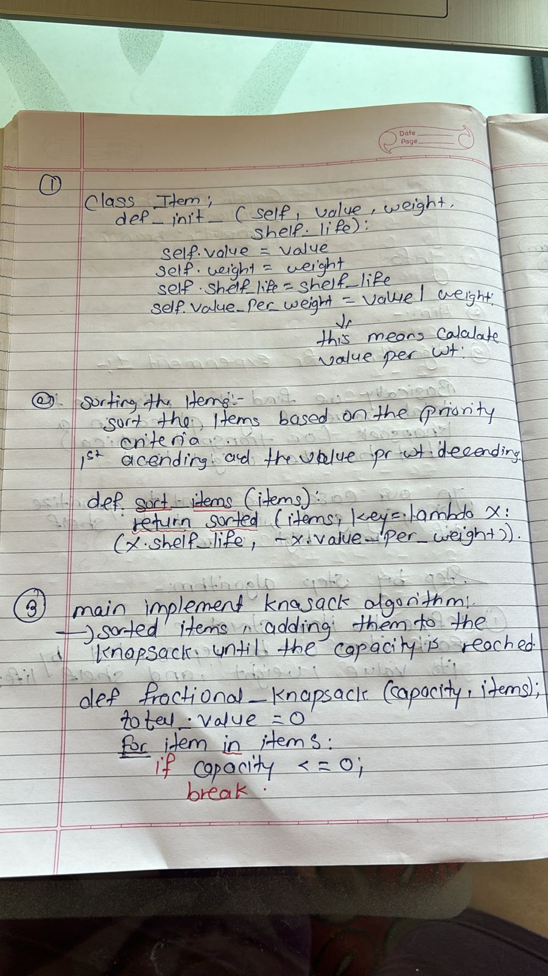

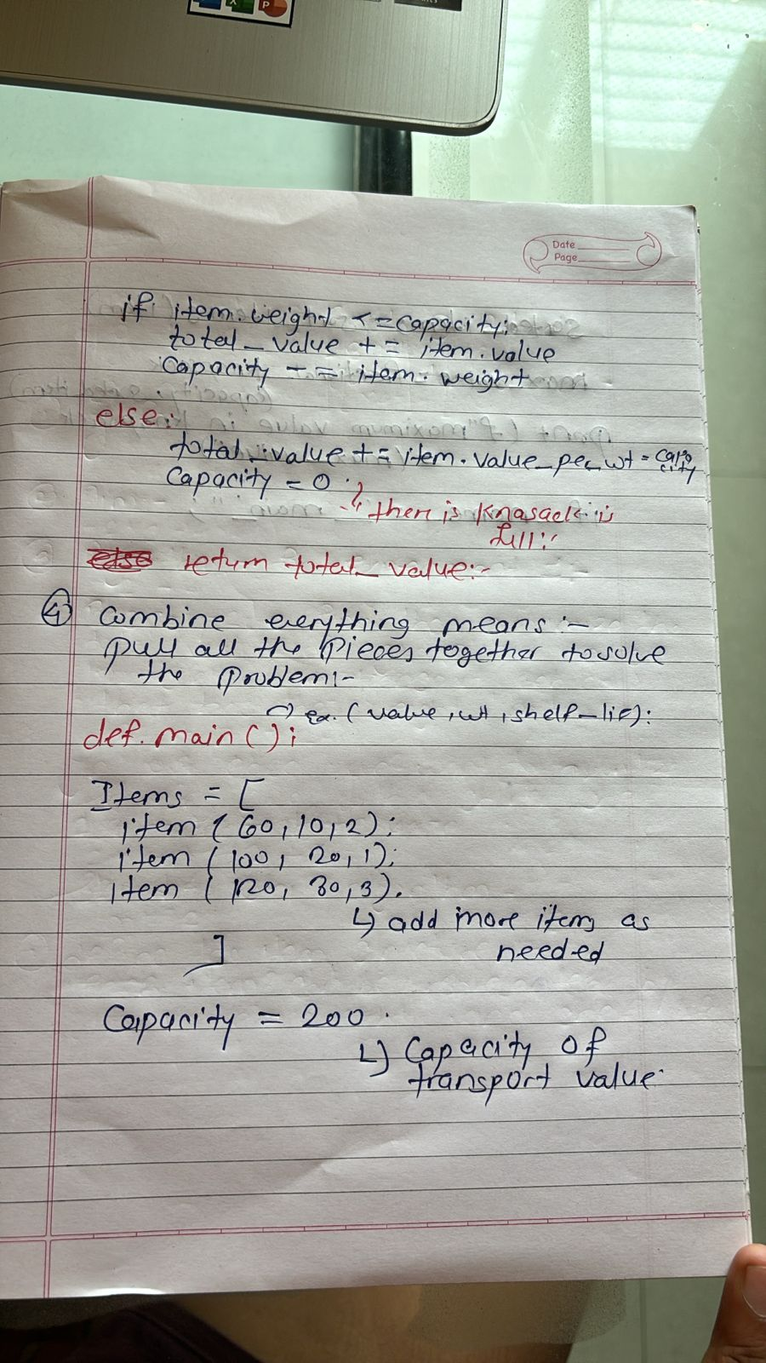

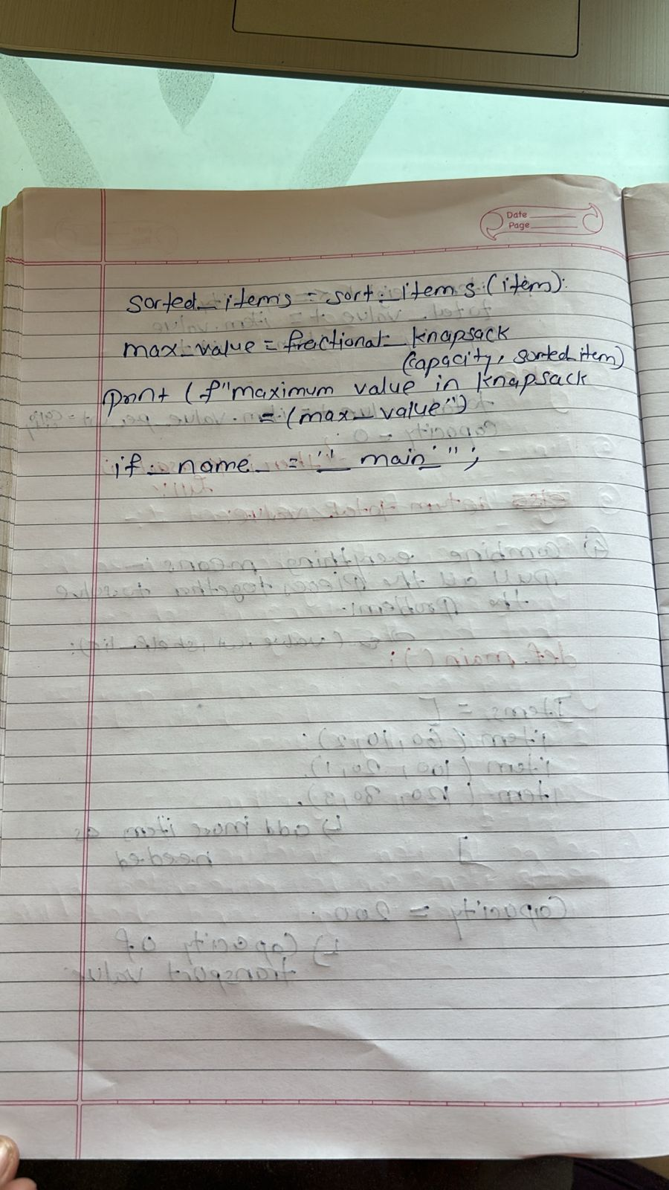

Algorithm for Experiment 2.

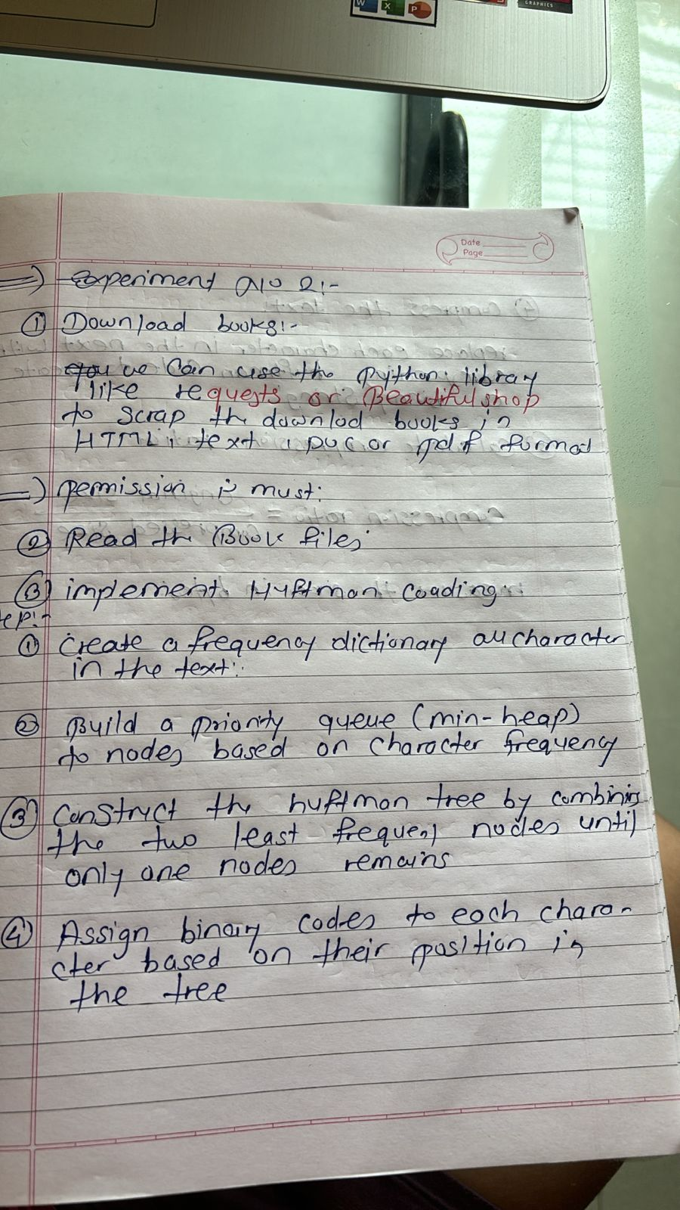

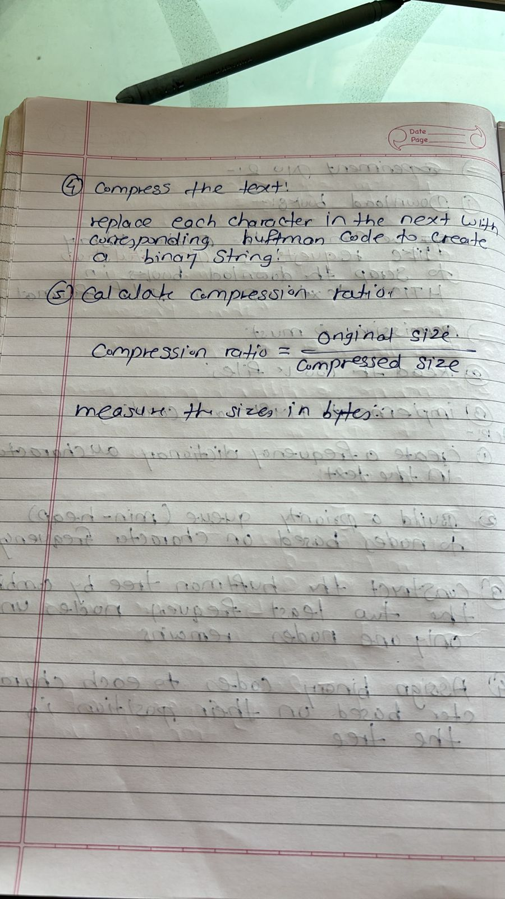

Time complexity for 1

